|  |  |  |
| --- | --- | --- |
| **Problem Chosen B** | **2025 MCM/ICM Summary Sheet** | **Team Control Number** 2524607 |

**Building a Balanced Future: Sustainable Tourism Development in Juneau’s Wilderness**

Juneau, known for its glaciers, rainforests, and wildlife, is a prime destination for tourists and eco-adventurers. While tourism significantly boosts the economy, overtourism presents notable challenges. This paper seeks to propose a **sustainable tourism model** for Juneau that balances economic growth, environmental preservation, and the well-being of local residents.

Two interconnected models are proposed: Model I: **Network Dynamic Entropy-AHP Evaluation Model** and Model II: **ARIMA with Measure Intervention**, which forecasts tourism development under the proposed measures. We develop sustainability indicators for urban tourism to evaluate policies and their impacts, incorporating long-term time series data into the ARIMA model.

For Objective I, our paper models the interactive effects of indicators using a two-level network structure. We apply ARIMA-MI to predict future indicators and **dynamically assess weights**, evaluating the effectiveness of measures over a **20-year horizon**. The optimal strategy for Juneau, derived from this model, includes limiting traffic, not restricting tourist numbers, increasing fees, and focusing on environmental protection. Our model incorporates three secondary indicators related to expenditures from additional revenue, with the resulting plan shown in the figure.

To assess factor importance, we calculated the **accumulated global weight** **(AGW)** based on dynamic weight calculations in the model. The results indicate that the most significant factors, in order of importance, are the characteristic tourism resources, economic sustainability, tourist numbers, and conservation expenditures. A sensitivity analysis was conducted to verify the reliability and accuracy of the AGW.

For Objective 2, we analyze city differences based on **city factors**, **initial conditions**, and **AHP weights**. Using Barcelona as a case study for over-touristed cities, we find that the most effective measures include limiting traffic, controlling tourist numbers, increasing fees, and supporting community protection. For less popular tourist cities, which face different challenges than Juneau, we extend our model with **counter-measures**. The first two measures are contrary to Juneau's strategy, while the last two align with it.

Additionally, we tested the model's adaptability by perturbing city indicators on a large scale to assess its performance across various overtourism contexts, verifying both its consistency with reality and its generalizability.

For Objective 3, we will provide the Mayor of Juneau with a non-technical report outlining our proposed measures, along with their expected outcomes and impacts.

**Keywords:** Sustainable tourism model、Network DE-AHP、AGW、ARIMA-MI

Content

1 Introduction 3

1.1 Problem Background 3

1.2 Restatement of the Problem 3

1.3 Our Work 4

2 Assumptions and Justifications 4

3 Notations 5

4 Evaluation Model：Network DE-AHP 5

4.1 Data Description 5

4.2 The Establishment of Model 1 6

4.2.1 System of indicators 6

4.2.2 Measure scenarios 9

4.2.3 Constructing the end goal 10

5 Prediction Model：ARIMA-MI 12

5.1 The steps for ARIMA-MI 12

6 Solution and Discussion 13

6.1 Juneau’s measure solution 13

6.2 Additional Expenditure Plan 14

6.3 Factor (secondary index) importance discussion and sensitivity analysi 15

7 Model Extension 17

7.1 Model Migration in overtourism destination：Barcelona 18

7.2 Promotion of the model in less touristy cities： 20

8 Model Evaluation and Further Discussion 21

8.1 Testing the model 21

8.2 Strengths 22

8.3 Weaknesses 23

References 25

# Introduction

## Problem Background

The Japanese wilderness photographer, Michio Hoshino, once stated: "The southern part of Alaska holds the sole remaining spiritual nature on Earth." Juneau, situated in the southern region of Alaska, boasts splendid scenery and immense charm. Attributed to its distinctive natural resources, it attracts a multitude of tourists. Juneau lies on a narrow stretch of land at sea level, bordered by the Pacific Ocean on the west and lofty mountains on the east. To enter or exit this capital of Alaska, one must either take a flight or a ferry. The terrain and climate here have also given rise to Juneau's unique local features, shaping the characteristic tourism industries of glaciers, whale watching, and rainforests. Nevertheless, the rapid increase in tourists has brought about the issue of overcrowding, undermining the sustainable development of the local tourism industry. Currently, Alaska has reached a new agreement to restrict cruise tourists and assist in combating excessive tourism.

The hidden costs within the tourism sector are increasingly impossible to disregard. These encompass the pressure on local infrastructure, the deterioration of the ecological environment, and the decline in the living standards of local residents. To alleviate the burden, the local government has adopted various measures, such as raising tourist taxes, to obtain additional revenue from tourism for the purpose of rectifying the corresponding hidden costs. Correctly accounting for and managing the hidden costs in the tourism industry constitutes a crucial aspect in balancing economic benefits and the sustainable development of tourism.

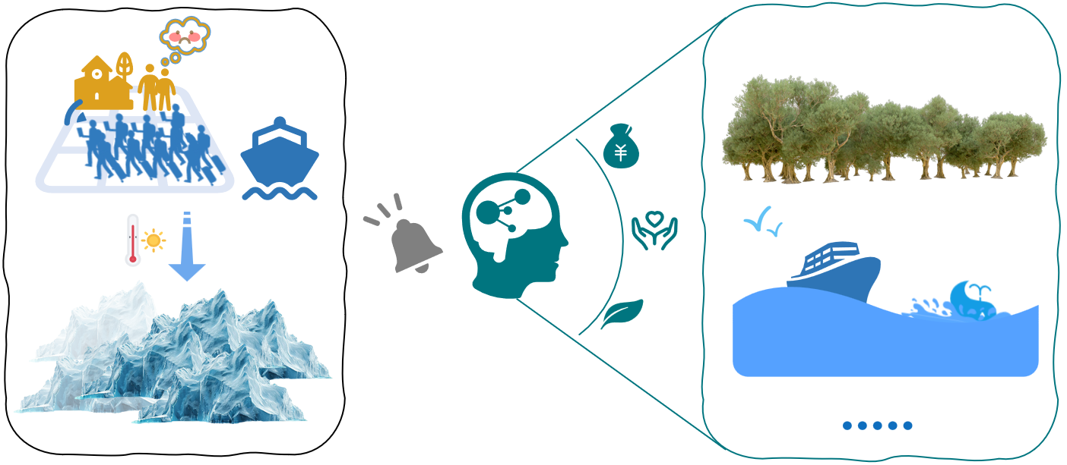

**Figure1：Background profile**

## Restatement of the Problem

Maasai Mara is renowned for its unique tourism resources, attracting visitors from all over the world. Our goal is to strike a balance among the environmental, social and economic aspects, thereby achieving sustainable development of tourism in Juno City.Considering the background information and restricted conditions identified in the problem statement, we need to solve the following problems:

* Task 1：Consider a range of measures that can be used to stabilise the tourism industry, develop a sustainable tourism model and identify optimising factors and constraints.
* Task 2：Use the model to develop an additional revenue expenditure scenario that makes the model promote sustainable tourism and discuss which factors are most important through a sensitivity analysis.
* Task 3：Examine the adaptability of the model as applied to other cities and consider how differences in location affect the choice of important measures.
* Task 4：Consider the above findings and provide a one-page memo to the City of Juneau Tourism Commission.

## Our Work

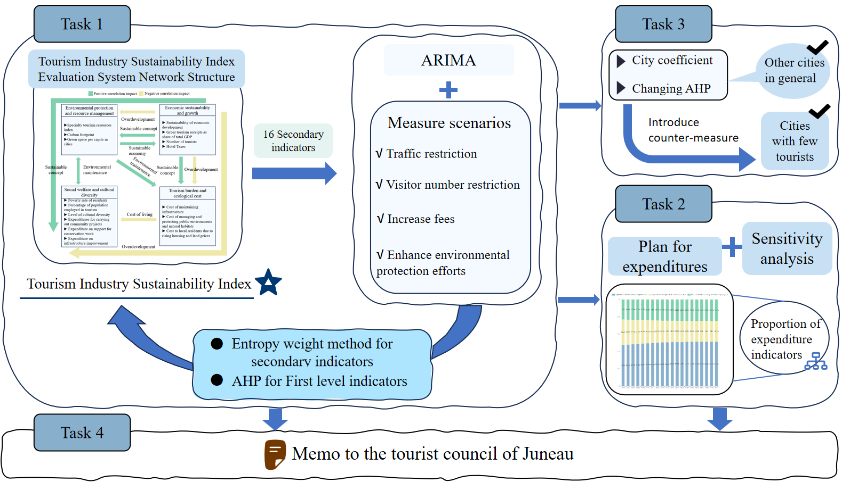

Figure2：Overview of our work

# Assumptions and Justifications

1. The model assumes that measures are implemented without endogenous delays or underfunding.

The model assumes that measures are implemented without endogenous delays or funding constraints. However, in practice, the implementation of measures is often a complex and lengthy process that can be affected by delays, budgetary constraints, and cancellations of measures by the government, which can result in the measures not being achieved as expected. It is assumed that funding is adequate and that there are no endogenous factors that would prevent the full implementation of the measures.

2. It is assumed that all data sources in this paper are authentic and reliable.

We need to rely on historical data from the City of Juneau to analyse the level of sustainability of the local tourism industry and to make projections for the near future. Therefore, the reliability of the data is very important.

3. For some of the hard-to-obtain data for the city of Juneau, data from the state of Alaska can be substituted.

Because some of the Juneau city data were difficult to obtain directly, we had to substitute relevant data from the State of Alaska. However, based on the known similarity of the data, we can conclude that the impact of this practice on model accuracy is within reasonable error limits.

# Notations

The key mathematical notations used in this paper are listed in Table 1.

Table 1: Notations used in this paper

|  |  |
| --- | --- |
| **Symbol** | **Description** |
|  | The value of the t-th secondary indicator within the s-th first-level indicator |
|  | The weight of the s-th first-level indicator |
|  | The weight of the t-th secondary indicator in the s-th first-level indicator |
|  | Global weight |
| GAW | Acuumulated global weight |
| $$X_{i}$$ | -1 indicates a reverse policy, 0 indicates no implementation, and 1 indicates policy implementation |

# Evaluation Model：Network DE-AHP

We construct a web-based evaluation model and define the tourism Sustainability Index as an indicator to measure the degree of tourism sustainability of a city. This index is determined by four first-level indicators: environmental protection and resource management, economic sustainability and growth, social welfare and cultural diversity, and tourism burden and ecological cost. These first-level indicators are dependent and interact with each other through various secondary indicator variables, and various measures will exert effects on each variable. We determined the weights of secondary indicators and first-level indicators respectively through the entropy method and the analytic hierarchy process, and formed the calculation rules of the Tourism Industry Sustainability Index. The higher the Tourism Industry Sustainability Index is, the better the tourism sustainability degree of the place is.

## Data Description

Finding available data became one of the most critical challenges as the question did not directly provide relevant data. By analysing the prerequisites of the mathematical model, we need to collect relevant information about the city of Juneau, such as the number of tourists, carbon footprint, glacier area and other indicators.

Although the title does not give the relevant data directly, we can get the relevant data about the tourism industry of Juneau City from the second reference of the title, ECONOMIC IMPACT OF JUNEAU'S CRUISE INDUSTRY.

Check the official website of the U.S. Geological Survey for data collected by the Juneau Ice Sheet Research Programme (JIRP). In addition, key data resources, including data websites and related references, are shown in Table 2 below.

Table 2：Data source collation：

|  |  |  |
| --- | --- | --- |
| **Data Description** | **Data Resources** | **Types** |
| Alaska tourism Trends and industry performance | https://www.alaskatia.org/resources/research | **Tourism** |
| Juneau Ice Field glacier monitoring data | https://alaska.usgs.gov/products/data/glaciers/benchmark_geodetic.php | **Ecology** |
| Greenhouse gas emissions | https://ghgdata.epa.gov/ | **Environment** |
| Social and economic structure data of Juneau City | https://fred.stlouisfed.org/categories/27412 | **Society、 econom** |

## The Establishment of Model 1

### System of indicators

We divide the tourism sustainability index into four primary dimensions: environmental protection and **resource** management, economic sustainability and growth, social welfare and cultural diversity, and tourism burden and ecological cost. To assess these primary dimensions, we establish secondary indicators based on the principles of scientific rigor, systematics, operability, and effectiveness, thereby forming a comprehensive evaluation system for tourism sustainability:

1. **Scientific Principle**: The selected indicators must accurately reflect the current state and future trends of tourism development. Data should be sourced from both long-term data and dynamic trends, ensuring authenticity. Additionally, predictive indicators for the future of tourism development in Juno may be incorporated, such as the growth trend of tourist numbers and the tourism sector’s contribution to GDP.

2. **Systematic Principle:** Tourism development is a multi-dimensional issue, involving environmental, economic, and social aspects. In constructing the sustainability evaluation system, it is essential to evaluate not only traditional economic benefits but also environmental sustainability, social effects, and the hidden costs of tourism as outlined in the study.

3. **Operability Principle:** To ensure data accessibility and the feasibility of the model, we prioritize the selection of quantitative data that is easily obtainable.

4. **Effectiveness Principle**：To ensure the distinctiveness and dynamism of the indicators, we focus on those that can reflect various aspects of tourism sustainability. Indicators should be flexible and adaptable to the specific characteristics of different cities. For example, some cities may place a greater emphasis on cultural heritage preservation, while others might focus more on environmental protection and resource conservation.

So we get the framework of tourism sustainability evaluation index system[1][2], as in Figure 3: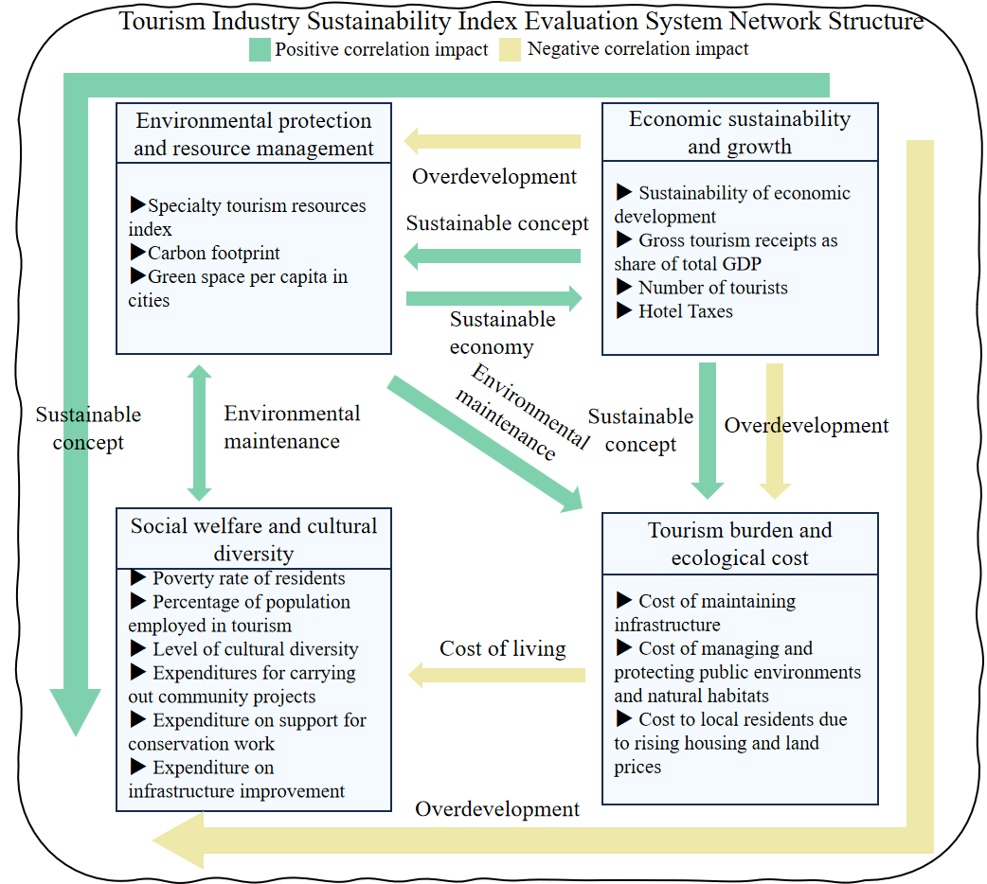

Figure3：Illustration of tourism industry sustainability evaluation index system

Variables in the secondary indicators that are difficult to obtain directly are described below:

● **Characteristic tourism resources index**：

As the characteristic tourism resources in the secondary indicators are abstract concepts, we establish the characteristic tourism resources index to quantify the index to establish a value assessment model, according to the background of the problem in the title can be divided into the index into glacier scores, rainforest scores, whale scores of the three first-level indicators, to get the characteristic tourism resources evaluation model shown in the table below:

Table3：Characteristic tourism resources index rating system

|  |  |
| --- | --- |
| **LevelⅠ Indicators** | **Secondary Indicators** |
| Glacier Score | Glacier area |
| Glacier height |
| Rainforest Score | Forest coverag |
| biodiversity |
| Whale Score | Whale population |
| Marine phosphorus concentration |

* **Biodiversity**：

We employ the Shannon-Wiener index ($H^{'}$) and Simpson's index ($D$) to calculate biodiversit[3]:

|  |  |
| --- | --- |
|  | () |

|  |  |
| --- | --- |
|  | () |

Where $p_{i}$ represents the fractional abundance of wildlife species $i$ for $i=1,2,…k$. It can be calculated using

|  |  |
| --- | --- |
| $$p_{i}=\frac{n_{i}}{N}$$ | () |

Where $n_{i}$ is the population of species $i$ and $N$ is total number of wildlife populations $N=\sum_{i=1}^{k}{n_{i}}$ for $i=1,2,…k$.

* **Carbon Footprint**（）：

In addition to ，there are other gases that contribute to the greenhouse effect, methane and nitrous oxide are additionally considered here.[4]In order to calculate the contribution of each gas, the Global Warming Plenipotentiary Parameter (GWP) is introduced, which compares the heating capacity of a given mass of greenhouse gases, and from this it is possible to calculate the effect of these different gases in the same unit of measurement（）.The calculation is as follows：

|  |  |
| --- | --- |
|  | () |

Where  stands for  emission， stands for  emission， stands for  emission，，，。

* **Green GDP(GGDP)**：

GGDP is used to measure the degree of sustainability of economic development:

1. Definition of Green GD：GGDP is a revision of traditional GDP, which takes into account the consumption of environmental resources, pollution emissions and other impacts on the environment, and thus can more accurately reflect whether the economic activities of a country or region have truly achieved sustainable development.

2. **Calculation method**：

·Traditional GDP: usually measures the total economic output of a country, without considering environmental costs.

·Green GDP: Based on the calculation of traditional GDP, environmental pollution (e.g., greenhouse gas emissions, air and water pollution) and depletion of natural resources (e.g., deforestation, depletion of mineral resources, etc.) resulting from production and consumption activities are deducted. Green GDP therefore emphasises a balance between economic growth and environmental protection.

The formula can be expressed as： $GGDP=GDP−EC−EP$,whereEC stands forEnvironmental costs，EP stands for Cost of ecological damage

### Measure scenarios

We consider optimisation measures to stabilise the tourism industry in an integrated manner, taking into account the economic, environmental and social dimensions.

* Measure 1: Restriction of traffic

The City of Juneau has a relatively limited road network and, especially during peak tourist seasons, the heavy flow of visitors from cruise ships can cause significant traffic congestion in the downtown area. Cruise ships often arrive at the same time, causing traffic pressure around the port, streets, and popular attractions, even affecting the daily lives of the local residents.

* Measure 2：Limiting the number of visitors

Many of the popular attractions in Juneau, especially the glacier and rainforest areas, have limited carrying capacity. Excessive tourist traffic can lead to overdevelopment and damage to local ecosystems, as well as undermine the uniqueness of natural landscapes and the visitor experience.

* Measures 3：Improving charge

By increasing hotel taxes and visitor fees, additional funds could be made available for environmental protection and infrastructure development. These additional revenues could be used to support conservation efforts and community projects at the infrastructure improvement level.

* Measures 4：Increasing support for environmental protection

The City of Juneau's natural beauty is a major attraction for visitors. Enhanced environmental protection will ensure that these unique attractions remain intact and can continue to attract visitors. In particular, sites as vulnerable to climate change as the Mendenhall Glacier must be effectively protected.

We consider specific measures for each optimisation factor, as well as secondary indicator variables that are more significantly affected by these optimisation factors, to design Table 3. Assuming that the change in annual passenger carrying capacity subject to toll increases and the change in glacier area, green space per capita in cities, and GGDP subject to environmental protection expenditures are linear, are denoted as、、、、，A linear regression model is considered here, which can be derived by fitting a univariate regression using the available data.

Table4:Measure scenarios

|  |  |  |
| --- | --- | --- |
| **measure** | **concrete measure** | **Measure influence coefficient** |
| Restriction of traffic (cruise ships) | The cruise will be closed 1 day a week, with 10% restricted access to featured attractions | environment：①Carbon footprint reduced by 1/70 ②The index of characteristic tourism resources increased by 1/70 |
| Economy：①Annual tourist arrivals fell by one seventh |
| Limiting the number of visitors | 50 fewer visitors from Sunday to Friday and 100 fewer visitors on Saturday | Economy：①The number of tourists decreased by 20,800 |
| Society：①Tourism revenue as a share of total GDP fell by 5 percent  ②The proportion of people employed in tourism fell by 5% ③The cost of rising house and land prices to local residents fell by 15% |
| Environment：①The cost of rising house and land prices to local residents fell by 15% ②The index of characteristic tourism resources increased by 1/500 |
| Improving charge | Increasing hotel tax and visitor fees by 10% | Economy：①Annual cruise ship capacity is down 10% ②Hotel taxes are up 10% |
| Society：①Spending on work such as community projects rise 10 percent ②Spending on work such as community projects rose 10% |
| Increasing support for environmental protection | Increasing spending on environmental protection by 30% | Environment：①30%eduction in carbon footprint ②Hotel taxes are up 10 percent30% ③Per capita urban green space increased by30% |
| Economy：①A 30% increase in the cost of managing and protecting the environment and natural habitats ②GGDP increased by 30% |

### Constructing the end goal

Calculation process for the final target

1. Hierarchical Analysis：

In determining the weights of the four level 1 indicators to construct the final Sustainability Tourism Index, we consider the extent to which sustainable tourism in the city values these four components. Therefore, we use a hierarchical analysis to avoid being too subjective in the choice of weights.

We created a judgment matrix for the City of Juneau ，Elements  indicates the importance of the i-th level indicator relative to the j-th level indicator for the sustainable development of tourism.

|  |  |
| --- | --- |
|  | () |

   

We obtain the weights of each component by computing the maximum eigenvalue and normalising its corresponding eigenvector.We use Consisting Ratio（CR）to check the consistency of each matrix，equation giving the formula $CR=\frac{CI}{RI}$，where $CI=\frac{λ_{max}−n}{n−1}$ and 𝑅𝐼 = 0.882（n=4）。Getting the CR of a matrix  0.1，Thus the consistency of the matrix is confirmed.

Therefore, the weights of the four level 1 indicators in our model are: ，，，。

2. Entropy Weighting System

Next, using the known data, the weights of the secondary indicators in the primary indicators to which they belong are calculated by the entropy weighting method.

The entropy weight method consists of the following steps：

* Matrix creation：We collected data on the secondary indicators for 20 years, from 2004 to 2023, and constructed matrices for the secondary indicator variables corresponding to the first level indicator. 。
* Normalisation of indicators. If the indicator is positive, the standardisation formula is directly followed:

|  |  |
| --- | --- |
| $$y_{ij}=\frac{x_{ij}−min(x_{.j})}{max(x_{.j})−min(x_{.j})}$$ | () |

If the indicator is negative, it is reversed in the standard formula：

|  |  |
| --- | --- |
| $$y_{ij}=\frac{max\left(x_{.j}\right)−x_{ij}−min(x_{.j})}{max(x_{.j})−min(x_{.j})}$$ | () |

* Find the information entropy of each variable, for the first variable:：

|  |  |
| --- | --- |
|  | () |

|  |  |
| --- | --- |
|  | () |

* Calculation of the weights of the indicators：

The above equation calculates the information entropy of T variables: $H_{1},H_{2}……H_{T}$，Calculate the weight of each secondary indicator.

|  |  |
| --- | --- |
| $=\frac{1−H_{t}}{P−\sum_{t=1}^{p}{H_{t}}}$ | () |

Combining entropy weighting and hierarchical analysis, the **Global Weight**(GW) of each secondary indicator were obtained:

|  |  |
| --- | --- |
|  | () |

* Our tourism sustainability index formula is defined as:

|  |  |
| --- | --- |
|  | () |

The implementation of different measures will have different effects on the values of the secondary indicators, and the weights of the secondary indicators and the Global Weight determined by them will then change, so that we can get the final score of the corresponding measures. It reflects the impact of the measure on the sustainability of tourism, and the higher the score, the more effective the measure.

# Prediction Model：ARIMA-MI

We integrate intervention measures into the ARIMA model to predict the tourism sustainability index over the next 20 years. The ARIMA-MI model accounts for both historical data and the dynamic impact of measure changes. Its strength lies in capturing long-term trends and adjusting future predictions based on policy interventions, making it ideal for forecasting the long-term effects of policy changes.

## The steps for ARIMA-MI

In Step 4, we established a sustainability index for tourism and identified four policy impact indicators, along with historical data. The dynamic prediction steps of the ARIMA-MI model are as follows:

**1.Build ARIMA Model Based on Initial Data:**

Input historical data: Use 15 years of secondary indicator data (2004–2023) as the time series input.

**Fit ARIMA model:**

Develop an initial ARIMA model based on historical data (without intervention measures), determining appropriate orders (p, d, q) through autocorrelation (ACF) and partial autocorrelation (PACF) analysis.

Dynamic introduction of measures: Each year, interventions affect secondary indicators, so these measures (e.g., strength, type, expected effect) are quantified and treated as external variables influencing the ARIMA model input.

**Dynamic Prediction and Iterative Update:**

Modify the ARIMA input data annually based on changes in intervention factors, creating “measure-adjusted” data.

Annual prediction: Using measure-adjusted data, make yearly predictions with the ARIMA model, considering previous results and the impact of that year's measures.

**Multiple Iterations and Long-term Forecasting:**

Each year's prediction becomes the input for the next, ensuring a recursive, dynamic update process.

Long-term prediction: Perform long-term forecasts using this dynamic ARIMA model for the next 20 years. The final forecast reflects the cumulative effect of annual measure interventions.

# Solution and Discussion

## Juneau’s measure solution

We import secondary indicator variables for time series forecasting and traverse 16 combinations of measures to obtain the tourism sustainability index of the 16 combinations of measures.

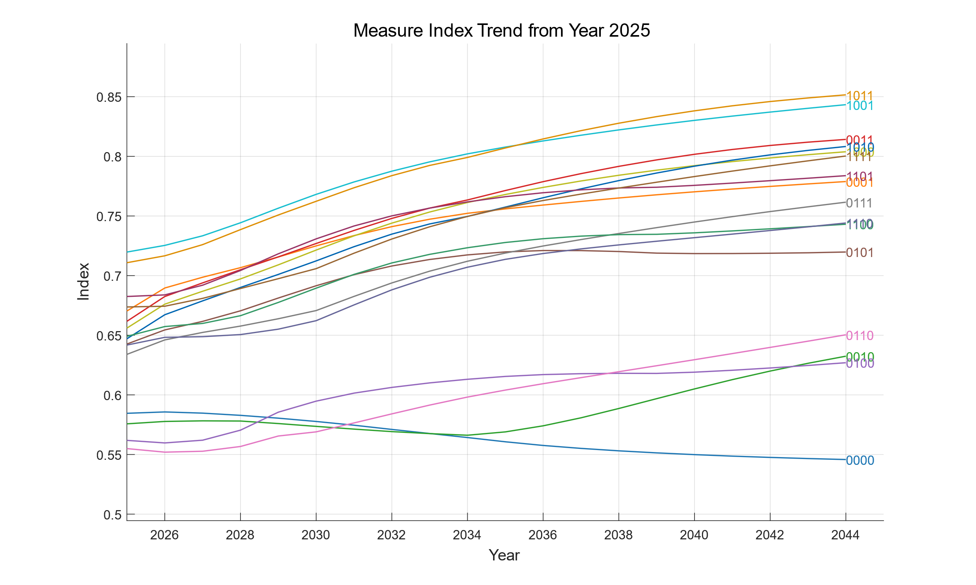

Figure4：Tourism Sustainability Index for 16 combinations of measures

The six programmes of measures with the highest tourism sustainability index are as follows：

Table5：6 measures with the highest tourism sustainability index

|  |  |  |  |  |  |
| --- | --- | --- | --- | --- | --- |
|  |  |  |  |  |  |
| √ |  | √ | √ | 0.8515 | 1 |
| √ |  |  | √ | 0.8433 | 2 |
|  |  | √ | √ | 0.8141 | 3 |
| √ |  | √ |  | 0.8082 | 4 |
| √ |  |  |  | 0.8038 | 5 |

Among these 16 measures, the optimal measure before 2035 is 1001—restricting traffic, not limiting tourist numbers, not raising fees, and improving the environment. After 2035, the best measure is 1011—restricting traffic, not limiting tourist numbers, raising fees, and improving the environment. This may be because 1001 attracts more tourists in the short term, while 1011 yields higher overall benefits once tourist numbers stabilize.

The results indicate that for Juneau, restricting traffic and enhancing the environment are essential, while limiting the number of tourists and raising fees are optional. Notably, the combination of raising fees and not restricting tourist numbers is more effective in the long term, while the opposite is true in the short term, outperforming other policies.

## Additional Expenditure Plan

Our model includes the following secondary indicators related to additional revenue expenditures: expenditures for community projects, expenditures to support conservation efforts, and expenditures to improve infrastructure, which are subordinate to social benefits and affect other benefits.

Based on the above solution, the 1011 measure is the best in the 20-year scale, and we will make recommendations to Juneau based on the ratio of the three generated by this policy combination.

Figure 5 shows that spending on infrastructure improvements increases annually from 47.5 per cent in 2025 to 51.2 per cent; spending on support for conservation decreases annually from 29.5 per cent in 2025 to around 24 per cent and stabilises; and spending on community projects increases annually from 23 per cent in 2025 to around 24.7 per cent and stabilises. The spending plans for the next 20 years reflect the increasing tendency to allocate a greater proportion of additional spending to the satisfaction of residents as the tourism sustainability index improves under the influence of best practice measures.

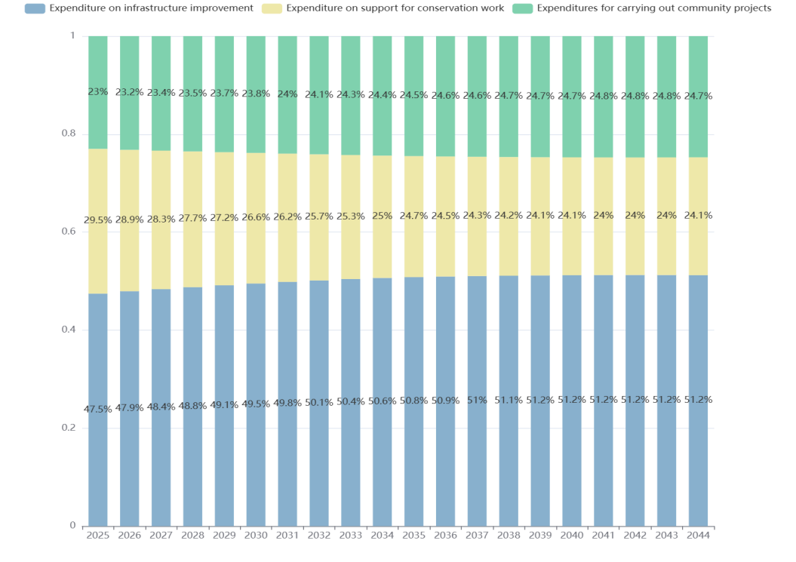

Figure5: Additional spending program

## Factor (secondary index) importance discussion and sensitivity analysi

Since our NDE-AHP dynamically calculates weights based on the time series of secondary indicators, in order to evaluate the importance of each indicator, we recorded the AGW (acuumulated global weight) of each indicator during the calculation process to measure the importance of factors.

The AGW results are as follows:

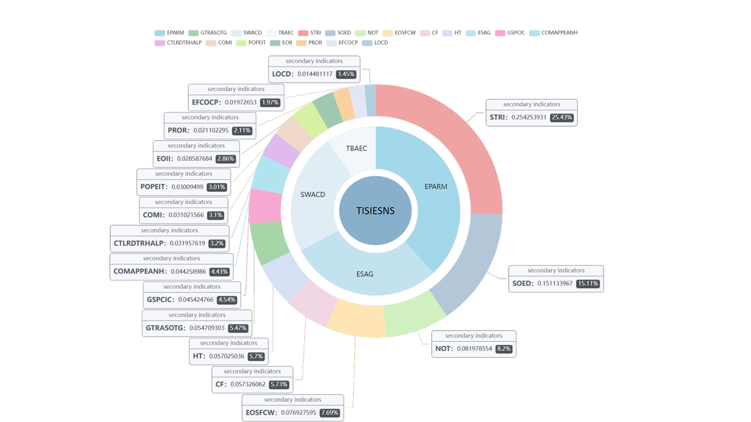

Figure6：The weights of the two-level indicators

The circle in the center of the figure is the abbreviation of the Tourism Sustainability Index. The circle surrounding the center of the figure is the abbreviation of the four first-level indicators. The outermost layer of the figure is 16 second-level indicators, among which STRI represents the characteristic tourism resource index, SOED represents the degree of sustainability of economic development, NOT represents the number of tourists, and EOSFCW represents expenditure on supporting conservation work.

To verify the correctness and reliability of AGW, we conducted a sensitivity analysis on the first six factors.

Since the AMN(ARIMAMI -Network DEAHP) model inputs time series data for each secondary indicator and measure factor, directly perturbing the time series would be smoothed out by standardization. Similarly, perturbing the final year's value could interfere with the ARIMA model. Therefore, we employ a local time series progressive interference method, gradually introducing disturbances over the last six years.

We control for other indicators and apply a progressive perturbation of ±6% to the time series of the top six indicators for the final six years. The results are as follows:

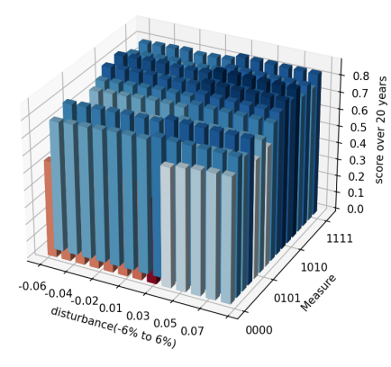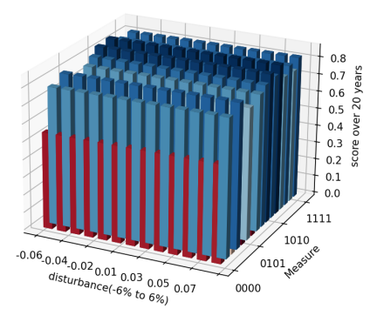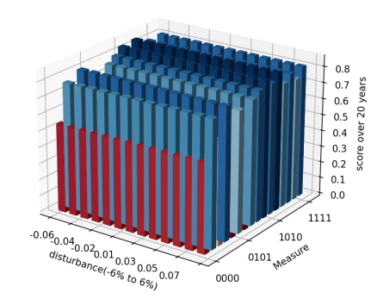

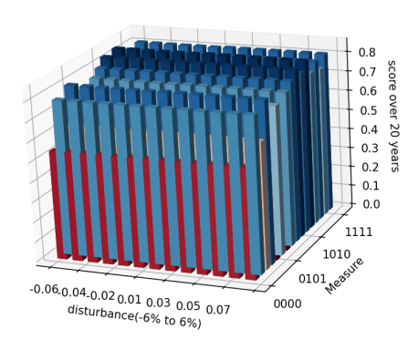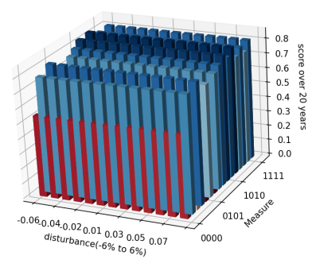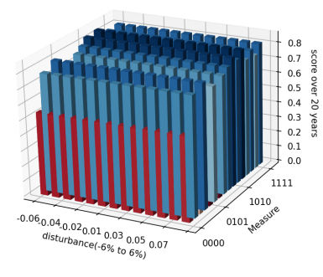

Figure7：Sensitivity analysis of the top six indicators.

The results confirm the correctness and reliability of AGW, showing that the model is more sensitive to secondary indicators with higher AGW. Furthermore, the AMN model is highly robust, as the characteristic tourism resource index, the most influential factor, is affected by less than 1% after disturbance. This stability arises from the complexity of the AMN model, which incorporates multiple interconnected factors and the added complexity of measure interventions, making the output resistant to the disturbance of a single factor.

# Model Extension

We test the transferability of the AMN model across different types of tourist cities. To adapt the model to new regions, we adjust parameters and introduce city coefficients, AHP coefficients, and negative decision variables to account for city-specific differences.

City coefficient: According to the characteristics of tourism in different cities, the implementation of different degrees of measures will affect the impact of the measures on the values of secondary indicators, and the initial values of secondary indicators in different cities are different.

AHP coefficient: In addition, different cities attach different importance to the four primary indicators, which will be reflected in the different weights of the primary indicators determined by AHP, which we call the AHP coefficient.

Reverse measures: The measures in section 4.2 target cities impacted by overtourism. For cities with lower tourism, reverse measures may apply. We modified the original 0-1 decision variable to a -1-0-1 decision variable.

For a city that is also affected by overtourism, the measures are implemented in the same direction, but the city coefficient, AHP coefficient and secondary index values are different. We obtain the specific correction coefficient through analysis and comparison. For a city with less tourism, we use different AHP coefficients, inherent coefficients, secondary index values ​​and inverse measures to describe its difference from Juneau. This reflects the good scalability of our model.

In applying the urban coefficients, we expect the intensity of measure implementation to translate:

* Restrictions on tourist traffic，（1+ $A$） days off per week， $A∈[−1,2]$
* Visitor numbers down by （50+ $B$） per day， $B∈\left[−50,50\right]$
* Hotel tax, tourist fee increase (10+ C) %， $C∈[−10,10]$
* Increase in expenditure on environmental protection (30+E) %， $E∈[−30,20]$

## 7.1 Model Migration in overtourism destination：Barcelona

By comparing the data for Barcelona and Juno, we can identify the indicators of change for model migration[5]:

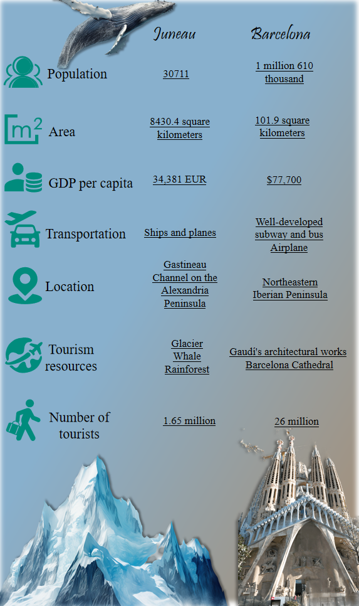

Figure8：The Difference between Juneau and Barcelona

Given the differences between Barcelona and Juneau in terms of economy, tourism resources, and population density, we propose the following adjustments to Barcelona's AHP coefficients and city factors:

**Different 1**： Compared to Juneau's tourism resources, which are more oriented toward natural landscapes and outdoor activities, Barcelona's distinctive tourism resources are more focused on architectural landmarks and historical sites.

**Coefficient Adjustment:** The city coefficient for expenditures on environmental protection can be appropriately reduced. In terms of AHP coefficients, the weights assigned to tourism burden and ecological cost should also be decreased compared to those in Juneau.

**Difference 2:** Barcelona's population density is significantly higher than that of Juneau. Compared to Juneau, the massive influx of tourists places a heavier burden on local infrastructure, such as restrooms, transportation, and parking facilities. Moreover, the flourishing tourism industry in Barcelona exacerbates the rise in land prices and the cost of living, further increasing the financial strain on local residents.

**Coefficient Adjustments:** Within the urban coefficients, hotel and visitor fees should be appropriately increased to better support community projects and infrastructure development. Simultaneously, tourism traffic and visitor numbers should be restricted. In the AHP coefficients, the weights for social well-being and cultural diversity should be increased compared to those of Juneau, reflecting their greater significance in Barcelona's context.

We constructed the judgment matrix and conducted a consistency check to ensure the reliability and validity of the weight assignments in the evaluation model.

The specific AHP coefficients and city parameters for Barcelona are detailed in the table below：

Table6：Construction of AHP coefficient and city coefficient of Barcelona city

|  |  |  |  |
| --- | --- | --- | --- |
| **AHP Cofficient** | | **City coefficient** | |
| EPM | 20% | Tourist traffic is closed （1+A）day per week | A=0.5 |
| ESG | 37.5% | The number of visitors decreased (50+B) per day | B=50 |
| SWD | 37.5% | Increased charges (10+D) % | D=10 |
| TBC | 5% | Increased spending on environmental protection (30+E) % | E=-20 |

Using this approach, we developed a Network DE-AHP evaluation model for assessing the sustainability index of Barcelona's tourism industry. Based on ARIMA-PI forecasting and Network DE-AHP evaluation, we derived the following results.

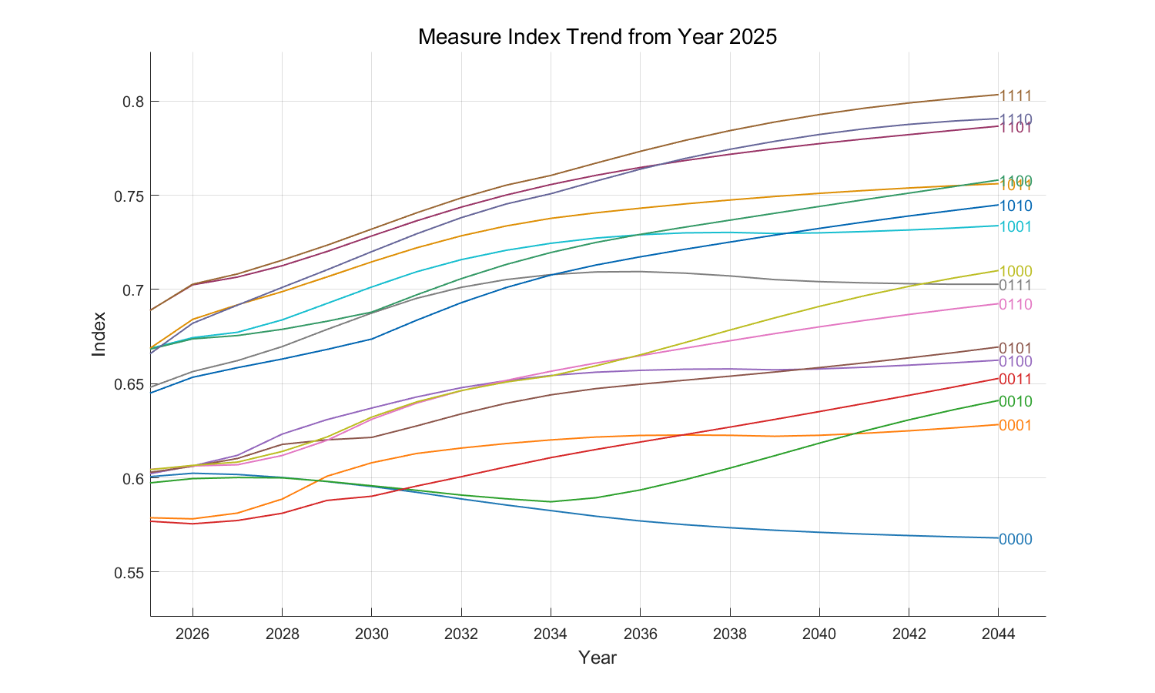

Figure9: Tourism Sustainability Index of Barcelona from 2025

It is evident that, unlike Juneau, the optimal policies for Barcelona are 1111, 1110, and 1101. Restricting the number of tourists is essential for Barcelona, along with limiting transportation, increasing fees, and strengthening environmental protection. Barcelona is a city facing significantly greater tourist inflows and environmental pressures compared to Juneau. We believe this outcome aligns well with the inherent differences between the two cities.

## 7.2 Promotion of the model in less touristy cities：

For cities with fewer tourists, the challenges they face are distinct from, and even opposite to, those of Juneau. Therefore, we differentiate these cities from Juneau not only in terms of urban factors, initial secondary indicators, and AHP weights but also by introducing the concept of "reverse policies" to expand the model. This approach allows policy variables to take negative values during the solution process—indicating the implementation of opposite measures, with corresponding opposite effects.

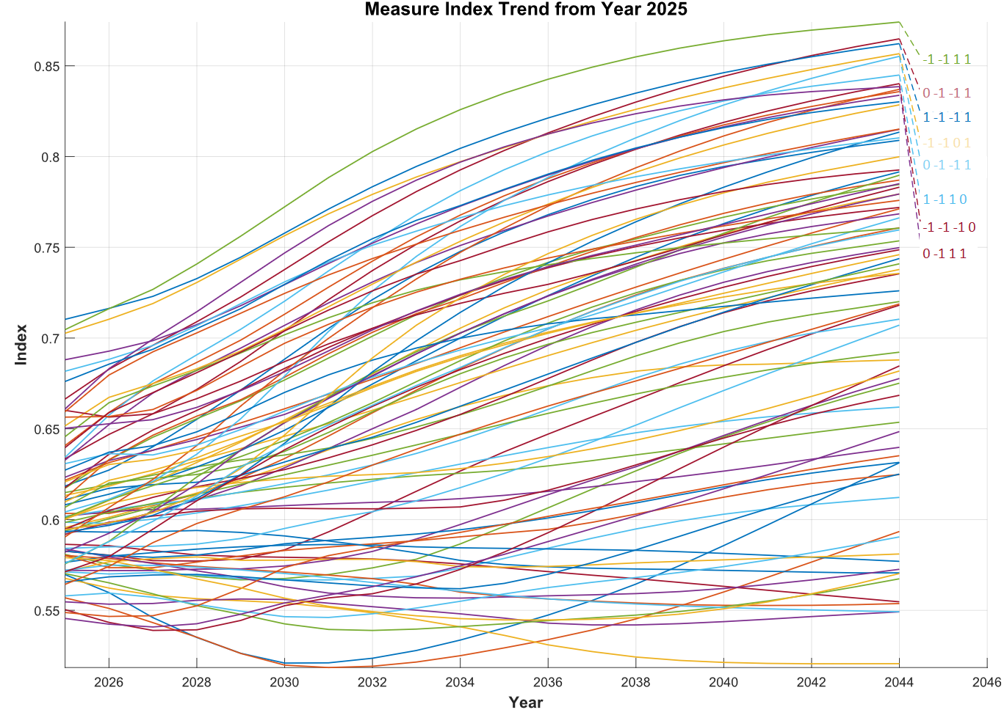

Figure 10: Tourism Sustainability Index in less touristy cities from 2025

Over a 20-year time scale, the optimal policy is -1, -1, 1, 1 — developing transportation, attracting tourists, increasing fees, and protecting the environment. Additionally, policies that could compete with -1, -1, 1, 1 for a certain period include 1, -1, -1, 1 (which outperformed -1, -1, 1, 1 in the early stages) and -1, -1, 0, 1 (which ranked just below the top two in the initial stages). However, in the later stages, -1, -1, 1, 1 emerges as the clear leader, while other policies exhibit dynamic competition.

These findings align with our expectations. As a less-popular tourist destination, this city is less burdened by concerns over environmental degradation and excessive tourist numbers, while it has a greater need to develop attractions and attract visitors. Meanwhile, environmental protection and community support remain relevant strategies for this city. Furthermore, increasing fees proves slightly less favorable than reducing or maintaining fees over a short time scale, but it demonstrates superiority over the latter options in the long term, corroborating our earlier discussions.

# Model Evaluation and Further Discussion

## Testing the model

The impact of measures in our model is more complex in real-world scenarios, necessitating perturbations of the policy factors to test the model's stability and certainty. Using Juneau's data, we perturb influence coefficient of four measure within the range of (-0.3, 0.3), yielding the following results:

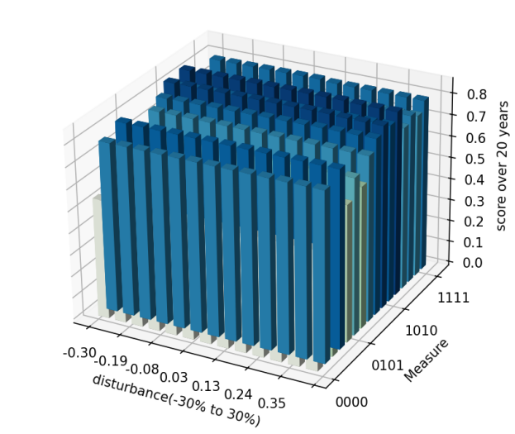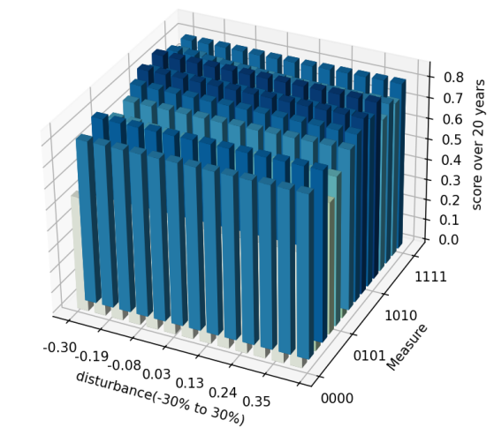

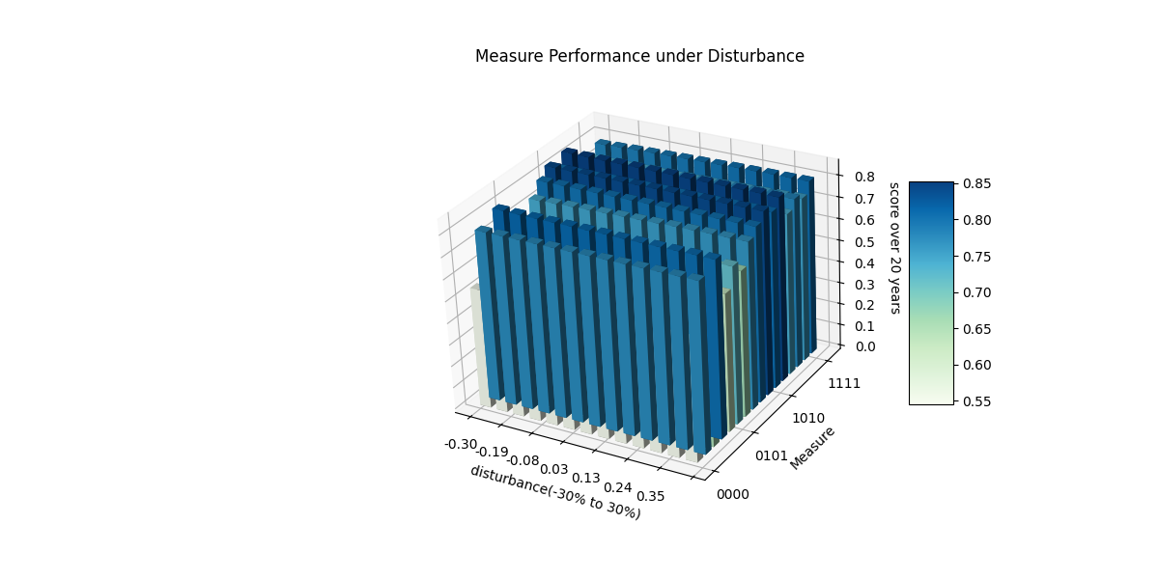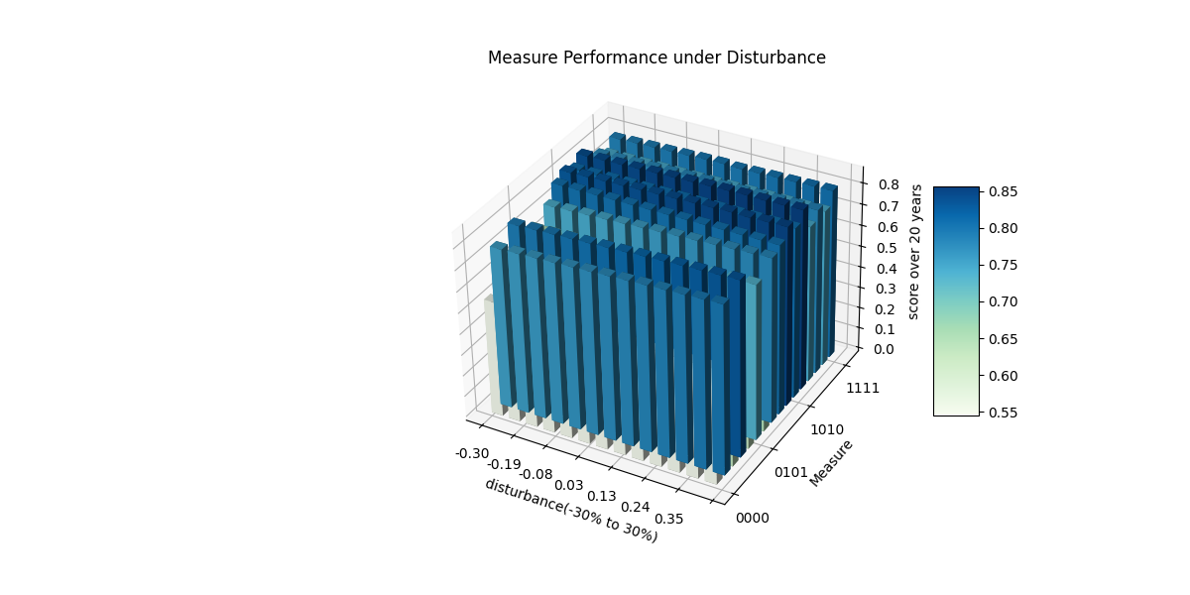

Figure11: Sensitivity analysis of the influence coefficients of the four measures.

This result shows that our model remains stable with parameter adjustments, allowing for reliable application to other tourist destination impacted by overtourism to assess policy rankings and outcomes

## Strengths

* Advantage 1: Consideration of Multiple Factors in Tourism Sustainability

Our model is designed based on the principles of scientific rigor, systematic structure, practical feasibility, and effectiveness. It incorporates a comprehensive evaluation framework for tourism sustainability, including but not limited to indicators such as tourism burden and ecological costs, distinctive tourism resource index, and carbon footprint. This approach effectively highlights the complexity of assessing tourism sustainability levels.

* Advantage 2: The Model Demonstrates Innovativeness

We introduced a dynamically adjusted ARIMA-PI model that accounts for the cumulative effects of measures in long-term forecasting. This innovation enables the model to more accurately predict the sustainability index over a 20-year horizon and better reflect the real-world impact of the implemented measures.

* Advantage 3: Utilizing an Index to Observe Dynamic Effects

By establishing an evaluation system, we quantified the abstract concept of tourism sustainability into a measurable Tourism Sustainability Index. This index is calculated through weighted averages based on dynamically assigned weights, where higher values indicate better combinations of measures. This approach provides an effective and straightforward method for analyzing the impact of various measures, and the results are easy to interpret and observe.

* Advantage 4: High Transferability of the Model

All factors were incorporated into a unified and robust framework, enabling the predictive solutions provided for Juneau to be equally applicable to other types of tourist cities. This adaptability highlights the versatility of the model in addressing diverse challenges faced by various destinations.

## Weaknesses

* Weakness 1: The model excludes the impact of unexpected events.

Over a 20-year time span, numerous unforeseen events are likely to occur. For instance, the sudden pandemic in 2020 led to a dramatic decline in tourism revenue, while natural disasters such as hurricanes and snowstorms pose significant threats to local tourism. Measures must be designed to swiftly adapt to a range of evolving events to comprehensively achieve the goal of sustainable tourism development.

* Weakness 2: The proposed measures involve a limited number of factors to simplify the model.

Therefore, in the application and promotion of the model, it is advisable to consider the impact of additional measures on the system, such as reducing promotional intensity and implementing environmental incentives. This would make the model more aligned with real-world scenarios.

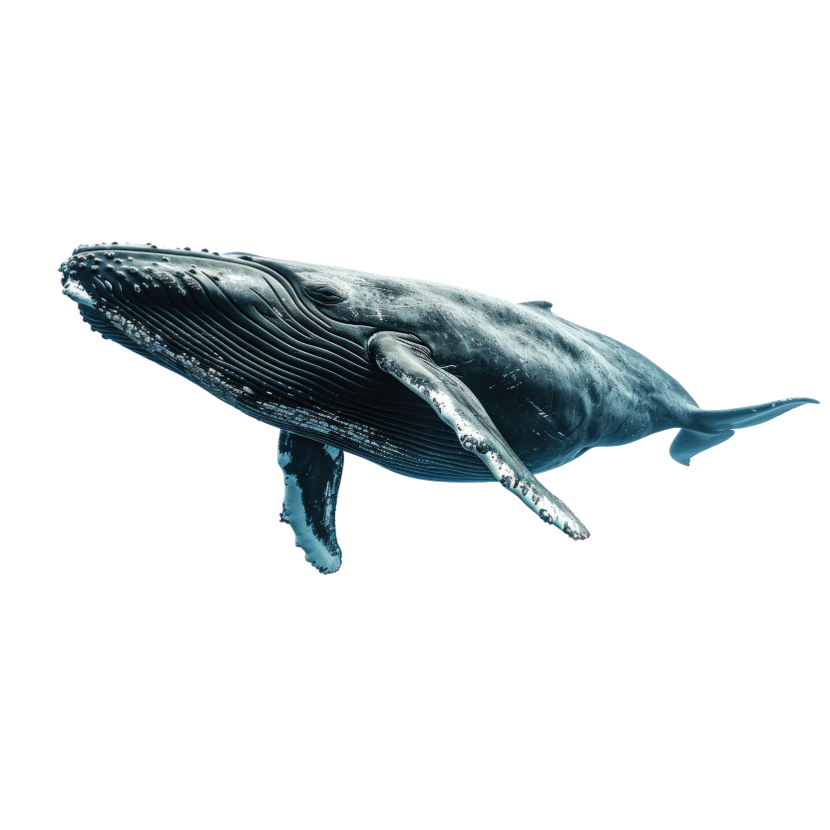To Tourist council of Juneau

From：team#2524607

Date：Jan 28, 2025

Theme: Tourism sustainability level, forecast and establishment of measures

Dear Tourist Council of Juneau:

Juneau is a paradise for eco-adventurers and attracts many tourists with its unique natural resources. However, the negative impact of overtourism on the environment and residents' lives needs urgent attention. Our team used scientific models to evaluate the sustainability of Juneau's tourism industry and provided data-driven policy recommendations.

We evaluated the sustainability of Juneau's tourism industry by building a comprehensive indicator system, and combined historical data and policy impacts to predict the sustainable development trend of tourism industry in the next 20 years under different measures. The study found that economic benefits, community satisfaction and ecological balance can be maximized by restricting traffic, optimizing charging items and strengthening environmental protection. Specific measures of this best measure include: cruise ships taking a day off per week, increasing hotel taxes and tourist fees by 10%, and increasing environmental protection spending by 30%.

The impacts of these measures vary. Cruise ship rest will effectively reduce carbon footprint, improve the characteristic tourism resource index (especially in the three core areas of glaciers, whales and rainforests), and may slightly reduce the number of tourists. Increasing fees will directly increase hotel taxes, but will also reduce the number of tourists. In addition, the additional income can be used for expenditures related to resident satisfaction, thereby improving social welfare. Increasing environmental protection efforts can not only further reduce carbon footprint, improve the characteristic tourism resource index and per capita green space, but also play a positive role in long-term sustainable economic development. According to our evaluation and forecast, adhering to this best practice can increase Juneau's tourism sustainability index from 0.72 in 2025 to 0.90 (full score 1) in 2044.

In addition, we have made specific suggestions for optimizing the expenditure structure. In the case where the additional revenue expenditure only involves improving infrastructure, supporting conservation work and carrying out community projects, we recommend that the expenditure ratio be: improving infrastructure 47.5%, supporting conservation work 29.5%, and carrying out community projects 23% starting from 2025. As the tourism sustainability index improves, the proportions of these three expenditures will eventually stabilize.

Although this study provides a systematic model and recommendations for the sustainable development of Juneau's tourism industry, we were unable to develop a more detailed and precise model and measures due to time constraints. However, we recommend further optimizing the indicator system, adding soft indicators such as visitor satisfaction and community participation, and establishing a resident and visitor feedback mechanism to incorporate feedback into the model optimization process. In addition, it is recommended to explore more policy combinations and evaluate their superposition effects to provide a more scientific decision-making basis for the sustainable development of Juneau's tourism industry.

We sincerely hope that it will provide you with useful information.

****Thank you!

# References

[1]Bramwell, B., Higham, J., Lane, B., and Miller, G. 2017. Twenty-five years of sustainable tourism and the Journal of Sustainable Tourism: Looking back and moving forward. *Journal of Sustainable Tourism* 25(1), 1-9.

[2]Sharpley, R. 2009. Tourism development and the environment: Beyond sustainability? *Earthscan*.

[3]Oindo, B.O., Skidmore, A.K. and de Salvo, P. 2010. Mapping habitat and biological diversity in theMaasai Mara ecosystem. International Journal of Remote Sensing 24(5), 1053-1069.

[4 United Nations Framework Convention on Climate Change (UNFCCC), Decision 24/CP.19 - Annex: GWP Values of Different Greenhouse Gases.

[5][DATA_SHEET_2022_cat-CN_1130.pdf](https://www.barcelona.cat/internationalwelcome/sites/default/files/DATA_SHEET_2022_cat-CN_1130.pdf)